Challenges and Solutions in Visualizing Global Land Temperature Trends Using Tableau

Bhakta Wachela, Julius Caesar, Yohanes Wiliam Hadiprojo, Jansen Wiratama

*Universitas Multimedia Nusantara, Jalan Scientia Boulevard Gading, Tangerang, 15810, Indonesia*

*Corresponding author:* [*bhakta.wachela@student.umn.ac.id*](mailto:bhakta.wachela@student.umn.ac.id)*,* [*yohanes.wiliam@student.umn.ac.id*](mailto:yohanes.wiliam@student.umn.ac.id)*,* [*julius.putra@student.umn.ac.id*](mailto:julius.putra@student.umn.ac.id)

***Abstract***— **This journal outlines the challenges and solutions encountered during the creation of data visualizations on global land temperatures using Tableau. The project involved three dashboards: geographic and temporal temperature patterns, quarterly temperature changes, and long-term trends with forecasting. Key issues included data accuracy, granularity, completeness, temporal and spatial resolution, uncertainty representation. Proposed solutions aim to enhance the accuracy, clarity, and interpretability of the visualizations, thereby improving their effectiveness in communicating the critical issue of rising global land temperatures.**

***Keywords***— **Global Land Temperatures; Data Accuracy; Uncertainty Representation; Forecasting.**

1. Introduction

Global land temperatures have been increasing gradually over the past century[1], posing significant environmental challenges. Effective visualization of this data is crucial for understanding trends, informing policy, and raising public awareness. This journal documents the process of creating comprehensive data visualizations using Tableau, highlighting the problems encountered and suggesting improvements to enhance the accuracy and impact of these visualizations.

1. Methodology
2. *Data Collection*

Data was sourced from a well respected organization namely Berkeley Earth in the form of Comma-Separated Value dataset that is published in Kaggle with the title ‘Climate Change: Earth Surface Temperature Data’.

1. *Data Preparation*

Data cleaning and preprocessing was not necessary since the provided dataset proves to be comprehensive dating back to the year 1743. But this proves to be unreliable in making the visualization since only a small number of countries were present. In making sure of the uniformity of data, it is agreed to take global land temperature data from the past century dating back to 1912 to ensure the most accurate data presentable.

1. *Data Visualization*

Tableau is the tool used to visualize the global land temperature data. The visualization includes a map visualization the average temperature from all the countries and also the corresponding country’s temperature change over the years, a major city visualization of temperature change over the years, the visualization of the data’s uncertainty with level of detail explaining the changing uncertainty based on the season(quarterly) and the visualization of how, over the last 100 years there has been a steady increase of temperature and a forecast predicting the increase of global land temperatures in the years to come.

1. Result and Discussion

Below is the visualization of global land temperature, each section is divided by dashboards of visualization that is deemed correlated to one another.

It is important to acknowledge that there may be some uncertainties in the data due to various factors. Data gaps, particularly in earlier records, can lead to incomplete trend analyses. Random errors and inconsistencies in data collection methods also contribute to uncertainty. Urbanization effects, such as the urban heat island phenomenon, can distort temperature readings, making it challenging to isolate broader climate trends[2].

1. *Average Temperature per Country and Major City*

The visualization for the average temperature for each country and major city is shown on *Fig. 1* This visualization consists of 4 *worksheets* that are combined into one dashboard. This dashboard is further consisted of 2 maps visualization and 2 line charts.

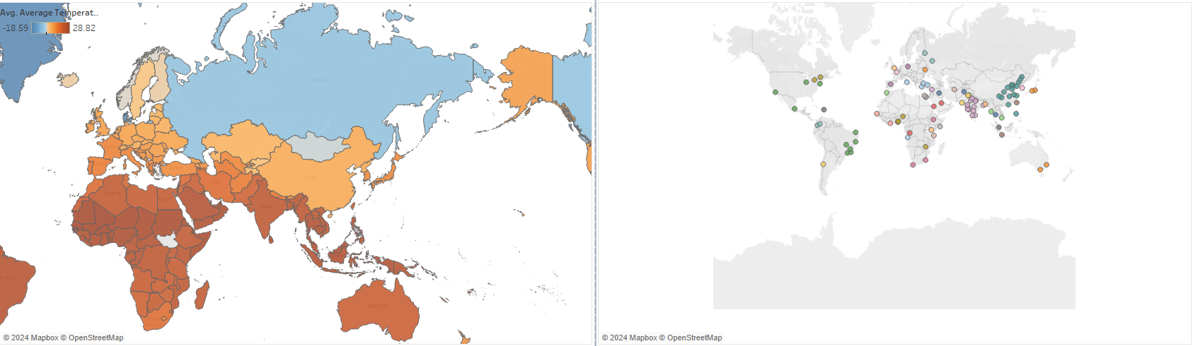

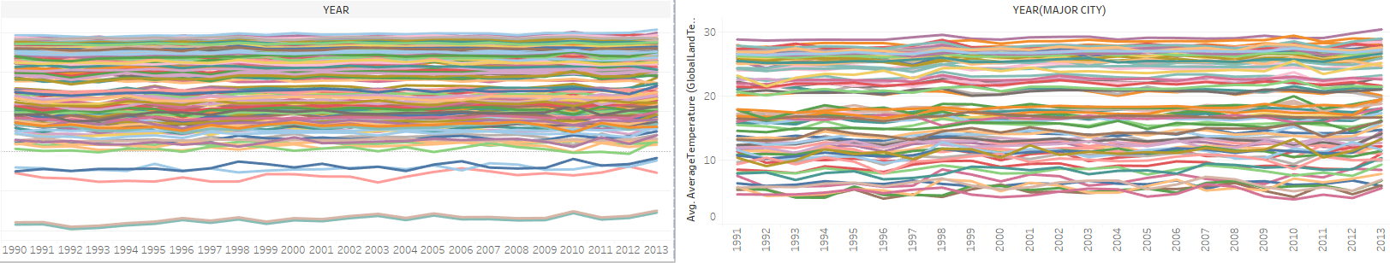

Fig. 1 The average temperature of countries and major city

The map on the left points out that there are countries with higher and lower average temperature throughout the earth with countries nearing the equator line having higher temperature average[3]. Countries near the equator experience high average temperatures due to the interaction of ocean and atmosphere, the shapes and arrangements of continents, and the presence of a thin layer in the ocean where the temperature changes rapidly with depth in the eastern equatorial parts of the Pacific and Atlantic Oceans[4].

The map on the right consists of major cities where the temperature change is recorded. It is important to understand when a country has one major city representation, the overall temperature data does not correlate to one another, this is also true if a country has multiple major city representation.

The line chart below the map visualization correlates to the yearly temperature changes. While convoluted, Fig.2 shows that it is possible to filter out a singular country or major city so that it is easier to analyze their respective temperature changes.

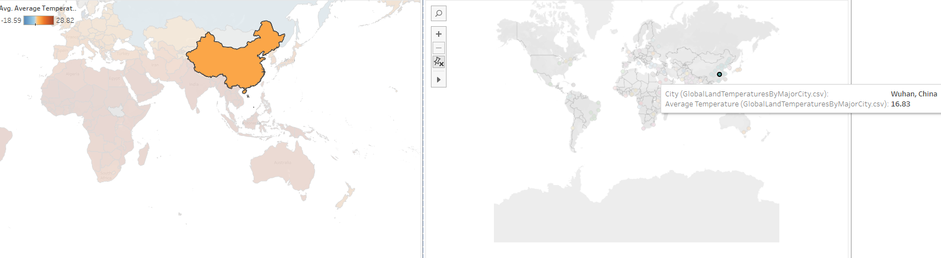

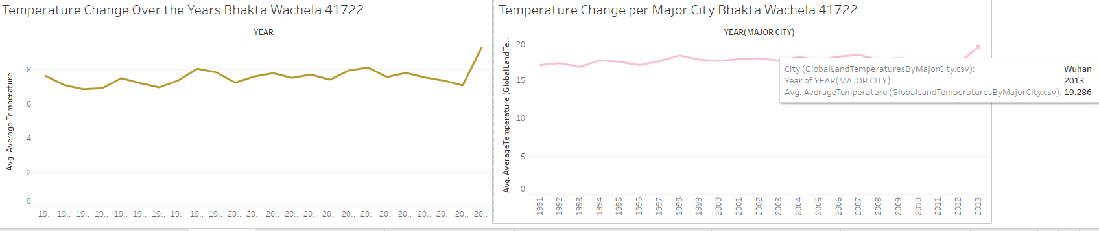

Fig. 2 Filtering to a specific country/major city

In this example, China is selected on the map to the left which shows the country’s yearly temperature change. From this visualization it's clear that China's average temperature reached its peak in 2013 reaching 9℃ . Map on the right however, shows the city Wuhan while the average temperature also peaked in 2013, it managed to reach 14℃. The collective data from each of China's regions and major cities contributes to the overall average temperature the country has reached.

The visualization of temperature trends in China over the past century reveals a steady upward trajectory. This increase in temperature can be attributed to various factors, with urbanization playing a critical role. China has experienced rapid urban growth, especially in the last few decades, leading to extensive land use changes.[5]

One of the most pronounced consequences of urbanization is the formation of urban heat islands (UHIs). Urban heat islands are metropolitan areas that experience significantly higher temperatures than their rural surroundings due to human activities and alterations in land surfaces[6].

In China, the urban heat islands are further exacerbated by severe haze pollution[7]. Haze not only deteriorates air quality but also traps heat, leading to higher temperatures in urban areas which increase mortality rate among other things[8].

1. *Quarterly Temperature change, Maximum Temperature per Country and Percentage Uncertainty*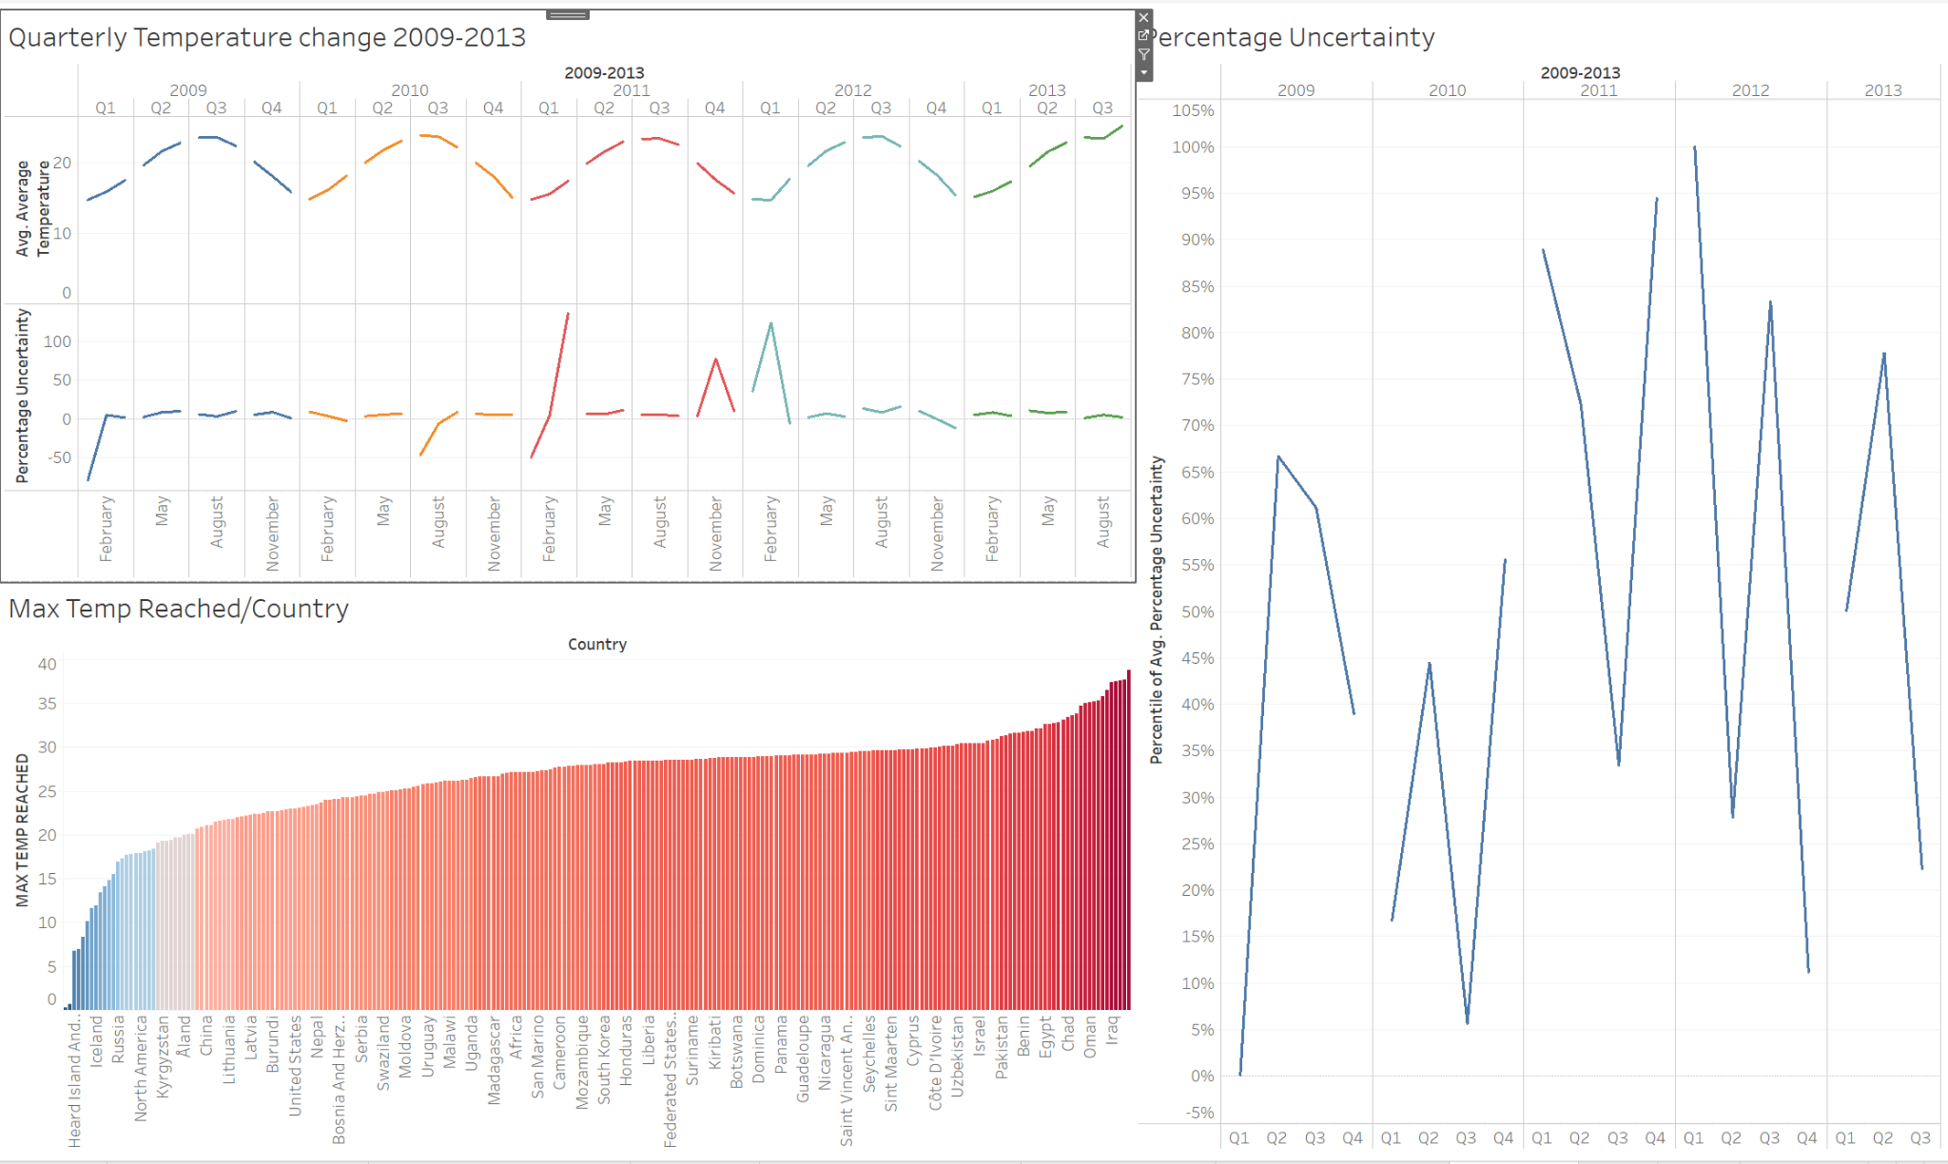

Fig. 3 Quarterly Temperature change, Maximum Temperature per Country and Percentage Uncertainty

Dashboard 2 (Fig. 3) offers a detailed analysis of global temperature data from 2009 to 2013, focusing on quarterly temperature changes, maximum temperatures reached per country, and the quarterly percentage uncertainty. This dashboard is essential for understanding recent temperature trends and their implications for climate change.

The quarterly temperature changes provide a granular view of how temperatures fluctuate within each year. Seasonal patterns are clearly visible, with temperatures peaking during the summer months (Q2 and Q3) and reaching their lowest during the winter months (Q1 and Q4). This cyclical nature is expected and aligns with known climatic cycles. However, an overarching trend emerges when examining the data year-over-year: there is a noticeable and steady increase in temperatures across all quarters over the five-year period. For instance, average temperatures in Q1 of 2009 are consistently lower than those in Q1 of 2013. This persistent increase in temperatures, albeit gradual on a quarterly basis, is indicative of a broader, long-term warming trend that aligns with global climate change predictions. This finding underscores the continuous impact of anthropogenic activities on global temperatures, reinforcing the need for sustained efforts to mitigate climate change.

The analysis of maximum temperatures reached per country during the period from 2009 to 2013 reveals significant regional variations. Countries located in tropical regions, particularly near the equator, recorded some of the highest maximum temperatures. For example, countries like Brazil, India, and Australia frequently experienced extreme temperatures that surpassed historical averages. In contrast, temperate and polar regions exhibited lower maximum temperatures but still showed increases relative to their historical records. This disparity in temperature extremes points to the uneven impact of global warming, where tropical regions bear the brunt of rising temperatures. The frequent occurrence of temperatures exceeding 40°C in these regions poses severe risks to public health, agriculture, and ecosystems, highlighting the urgent need for localized climate adaptation strategies. These strategies could include developing heat-resistant crop varieties, improving urban infrastructure to cope with extreme heat, and enhancing public health systems to manage heat-related illnesses[9].

The quarterly percentage uncertainty provides crucial insights into the reliability and accuracy of the temperature data. The uncertainty values vary significantly across different quarters, reflecting the inherent challenges in collecting and measuring temperature data accurately. For example, Q3 of 2010 might show higher uncertainty due to data collection issues during the peak summer months, possibly influenced by atmospheric phenomena like El Niño[10]. High levels of uncertainty can obscure true temperature trends and complicate efforts to draw definitive conclusions[11]. This variability underscores a critical challenge in climate data analysis: the need for robust, standardized measurement practices to minimize uncertainty and improve data reliability. Addressing these uncertainties is essential for creating more accurate and trustworthy visualizations that can effectively inform policy decisions[12]. Enhancing measurement techniques, increasing the density of monitoring stations, and leveraging satellite data could help reduce these uncertainties.

1. *Long Term Temperature Trends and Forecasting*

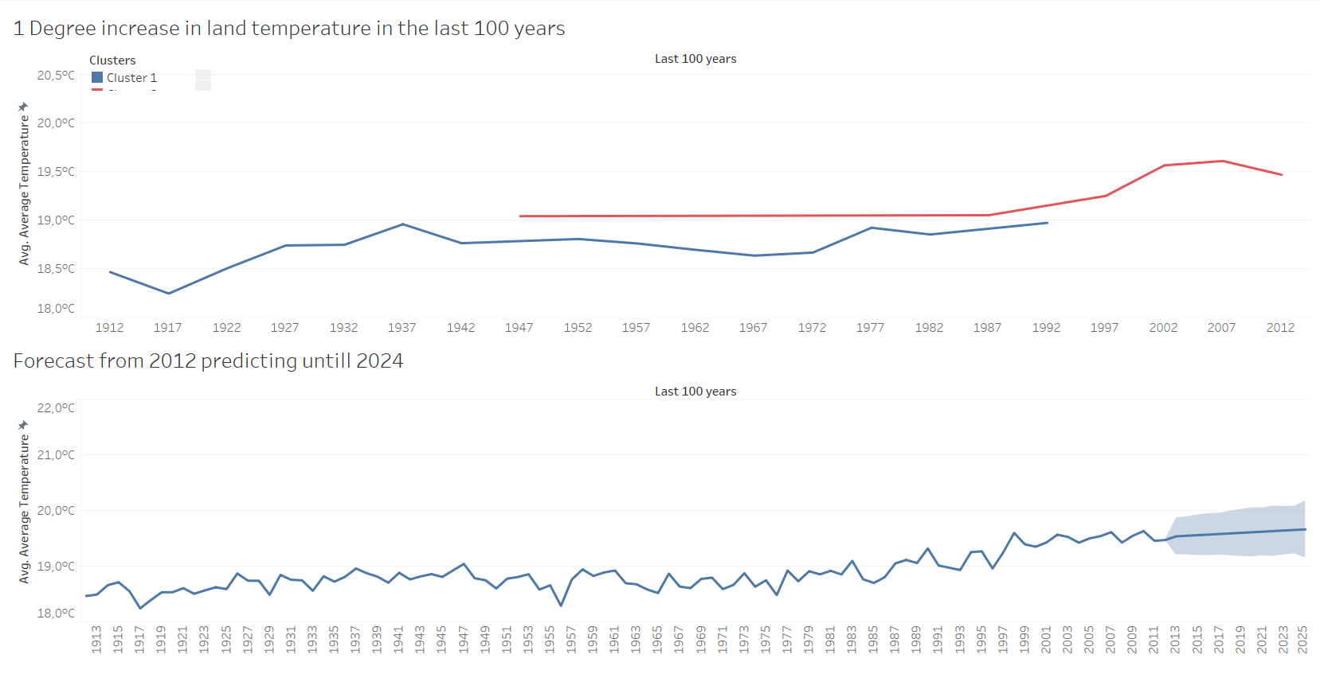

Fig. 4 Land Temperature Degree Increase and Forecast Predict

The first visualization is a line chart with two notable clusters highlighting significant milestones in global land temperature records. The chart shows the historical progression of average global land temperatures, with a particular emphasis on the year 1947. This year marks the first recorded instance of the average global land temperature reaching 19°C. This milestone is crucial as it signifies a pivotal point in the ongoing trend of global warming, illustrating the progressive shift in baseline temperatures over the 20th century. In 2007, global land and ocean temperatures were among the warmest on record, with the average land temperature being the warmest since global records began in 1880[13]. The decade from 2000 to 2009 was the warmest on record in history. This warming trend coincided with a continued rise in atmospheric greenhouse gas concentrations, with CO2 levels increasing at a rate surpassing the average from 1978 to 2008[14].

The second visualization illustrates the steady increase in average global land temperatures[15] from 1912 to 2013. This steady increase is mostly due to human activities [16] This line chart provides a clear depiction of how average temperatures have risen over the past century. The visualization highlights a consistent upward trajectory, with notable acceleration in recent decades[17]. This long-term data underscores the persistent and escalating nature of global warming.

It is crucial to note that the forecast utilized for predicting global land temperatures up to 2025 may lack precision, as it relies on an automated formula integrated into the Tableau software, which was utilized for this analysis. The latest global land temperature report, encompassing anomalies in Celsius up to the year 2023, is readily accessible on the Berkeley Earth website[18]. This comprehensive report provides detailed insights into the deviations from the long-term average temperature, offering valuable data for researchers, policymakers, and the public alike.

1. Conclusion

In summary, this journal has delved into the challenges encountered and solutions proposed during the creation of data visualizations on global land temperatures using Tableau. Through three comprehensive dashboards, we explored geographic and temporal temperature patterns, quarterly temperature changes, and long-term trends with forecasting. Key issues such as data accuracy, granularity, completeness, temporal and spatial resolution, and uncertainty representation were addressed, with proposed solutions aiming to enhance the accuracy, clarity, and interpretability of the visualizations.

Moving forward, mitigating climate change and global warming requires concerted efforts. The implementation of innovative methodologies, such as the X-11 seasonal adjustment approach, offers a promising avenue for further research. By accommodating significant year-to-year variations in seasonality, this approach not only improves climate variability diagnosis but also holds potential for enhancing seasonal climate forecasts. Integrating such methodologies into climate modeling and forecasting can contribute to more accurate predictions and informed decision-making in climate adaptation and mitigation strategies[19].

Moreover, there is a pressing need for interdisciplinary collaboration and continued research to advance our understanding of climate dynamics and improve climate change mitigation efforts[20]. Future studies could explore novel approaches to data collection and analysis, refine existing models to better capture complex climate interactions, and investigate the effectiveness of various mitigation measures. By fostering a culture of innovation and collaboration, we can collectively address the multifaceted challenges posed by climate change and work towards a sustainable and resilient future.

Acknowledgment

We would like to thank Berkeley Earth for providing invaluable data and datasets for creating the visualizations in this Project. A more revised and updated data can be found on Berkeley Earth’s website (<https://berkeleyearth.org/data/>)

References

1. Hansen, J., Ruedy, R., Sato, M., & Lo, K. (2010). Global surface temperature change. Reviews of Geophysics, 48(4). <https://doi.org/10.1029/2010RG000345>
2. Folland, C. K., Rayner, N. A., Brown, S. J., Smith, T. M., Shen, S. S. P., Parker, D. E., Macadam, I., Jones, P. D., Jones, R. N., Nicholls, N., & Sexton, D. M. H. (2001). Global temperature change and its uncertainties since 1861. *Geophysical Research Letters*, *28*(13). <https://doi.org/10.1029/2001GL012877>
3. Bathiany, S., Dakos, V., Scheffer, M., & Lenton, T. M. (2018). Climate models predict increasing temperature variability in poor countries. *Science Advances*, *4*(5). <https://doi.org/10.1126/sciadv.aar5809>
4. Philander, S. G. H., Gu, D., Halpern, D., Lambert, G., Lau, N. C., Li, T., & Pacanowski, R. C. (1996). Why the ITCZ is mostly north of the equator. *Journal of Climate*, *9*(12). <https://doi.org/10.1175/1520-0442(1996)009><2958:WTIIMN>2.0.CO;2
5. Textor, C. (2021). *Degree of urbanization in China from 1980 to 2020*. Statista 2021.Available: <https://www.statista.com/statistics/270162/urbanization-in-china/>
6. Mohajerani, A., Bakaric, J., & Jeffrey-Bailey, T. (2017). The urban heat island effect, its causes, and mitigation, with reference to the thermal properties of asphalt concrete. In *Journal of Environmental Management* (Vol. 197). <https://doi.org/10.1016/j.jenvman.2017.03.095>
7. Cao, C., Lee, X., Liu, S., Schultz, N., Xiao, W., Zhang, M., & Zhao, L. (2016). Urban heat islands in China enhanced by haze pollution. Nature Communications, 7. <https://doi.org/10.1038/ncomms12509>
8. Ho, H. C., Wong, M. S., Yang, L., Shi, W., Yang, J., Bilal, M., & Chan, T. C. (2018). Spatiotemporal influence of temperature, air quality, and urban environment on cause-specific mortality during hazy days. *Environment International*, *112*. <https://doi.org/10.1016/j.envint.2017.12.001>
9. Gauer, R., & Meyers, B. K. (2019). Heat-related Illnesses. American Family Physician, 99(8). <https://doi.org/10.29309/tpmj/2015.22.05.1264>
10. McPhaden, M. J. (2004). Evolution of the 2002/03 El Niño. *Bulletin of the American Meteorological Society*, *85*(5). <https://doi.org/10.1175/BAMS-85-5-677>
11. Hawkins, E., Smith, R. S., Gregory, J. M., & Stainforth, D. A. (2016). Irreducible uncertainty in near-term climate projections. Climate Dynamics, 46(11–12). <https://doi.org/10.1007/s00382-015-2806-8>
12. Reilly, J., Stone, P. H., Forest, C. E., Webster, M. D., Jacoby, H. D., & Prinn, R. G. (2001). Climate change: Uncertainty and climate change assessments. In Science (Vol. 293, Issue 5529). <https://doi.org/10.1126/science.1062001>
13. Levinson, D. H., & Lawrimore, J. H. (2008). State of the Climate in 2007. Bulletin of the American Meteorological Society, 89(7). <https://doi.org/10.1175/BAMS-89-7-StateoftheClimate>
14. Arndt, D. S., Baringer, M. O., Johnson, M. R., Alexander, L. v., Diamond, H. J., Fogt, R. L., Levy, J. M., Richter-Menge, J., Thorne, P. W., Vincent, L. A., Watkins, A. B., & Willett, K. M. (2010). State of the climate in 2009. *Bulletin of the American Meteorological Society*, *91*(7). <https://doi.org/10.1175/BAMS-91-7-StateoftheClimate>
15. Jones, P. D., New, M., Parker, D. E., Martin, S., & Rigor, I. G. (1999). Surface air temperature and its changes over the past 150 years. Reviews of Geophysics, 37(2). <https://doi.org/10.1029/1999RG900002>
16. Dickinson, R. E., & Cicerone, R. J. (1986). Future global warming from atmospheric trace gases. Nature, 319(6049). <https://doi.org/10.1038/319109a0>
17. Li, Q., Sun, W., Yun, X., Huang, B., Dong, W., Wang, X. L., Zhai, P., & Jones, P. (2021). An updated evaluation of the global mean land surface air temperature and surface temperature trends based on CLSAT and CMST. Climate Dynamics, 56(1–2). <https://doi.org/10.1007/s00382-020-05502-0>
18. Robert, R “Global Temperature Report for 2023,” Berkeley Earth, Berkeley, CA, USA, Jan. 12, 2024. [Online]. Available:<https://berkeleyearth.org/global-temperature-report-for-2023/>
19. Pezzulli, S., Stephenson, D. B., & Hannachi, A. (2005). The variability of seasonality. Journal of Climate, 18(1). <https://doi.org/10.1175/JCLI-3256.1>
20. Colven, E., & Thomson, M. J. (2019). Bridging the divide between human and physical geography: Potential avenues for collaborative research on climate modeling. Geography Compass, 13(2). <https://doi.org/10.1111/gec3.12418>